**Auto Scaling**

Step1: Create EC2 instance and configure the security group.

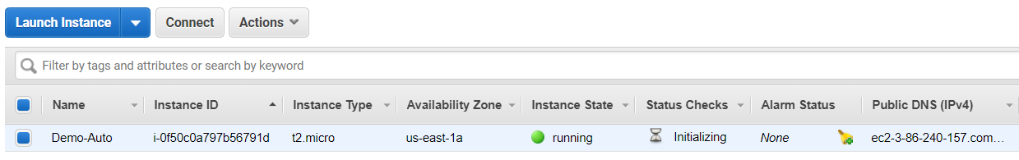

Step2: Create AMI

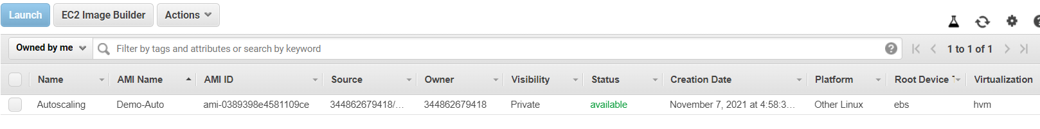

Step3: Switch to Autoscaling and click create launch configuration.

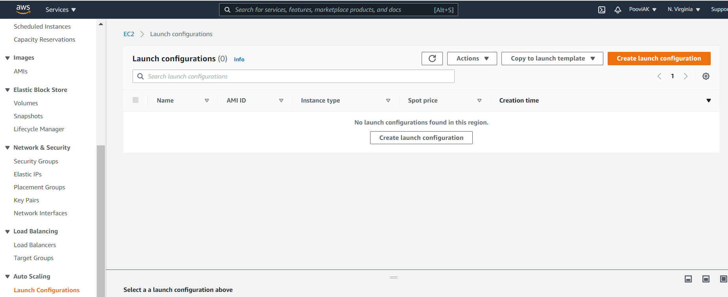

Step4: Here select AMI, instance type, security groups, storage and keypair.

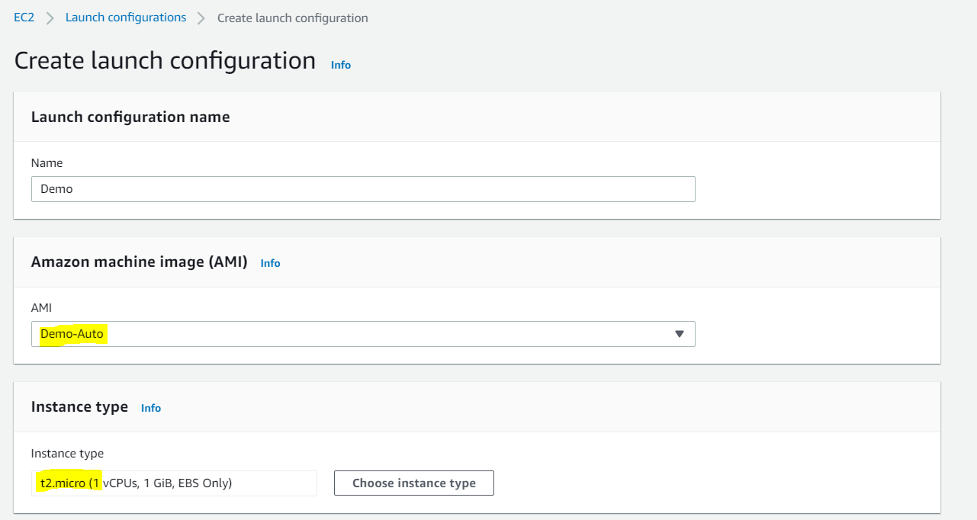

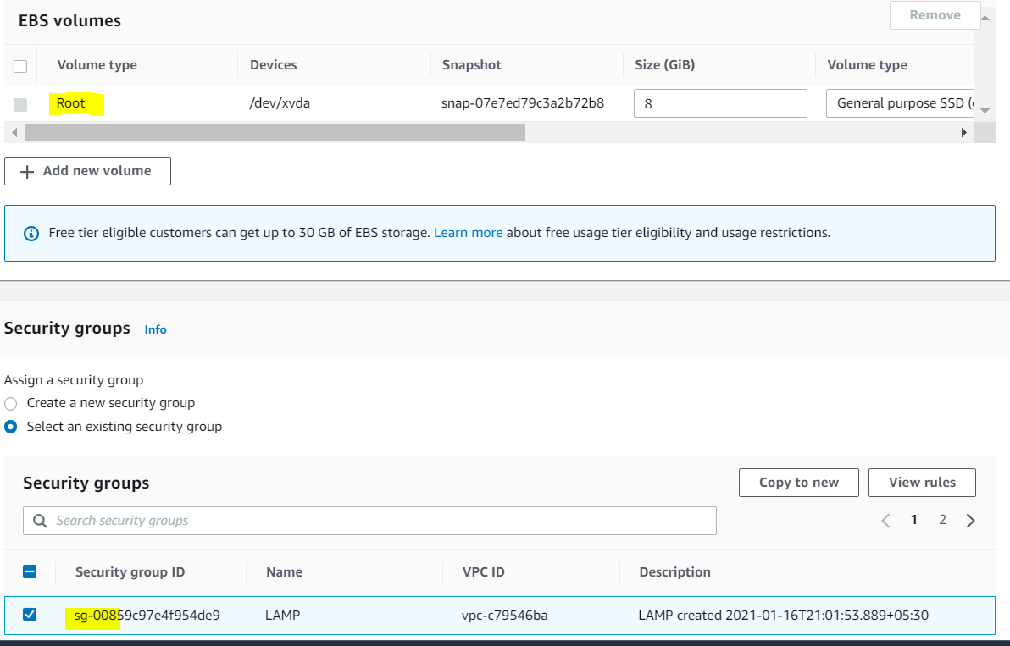

Once done all configuration accept check list and click create launch configuration.

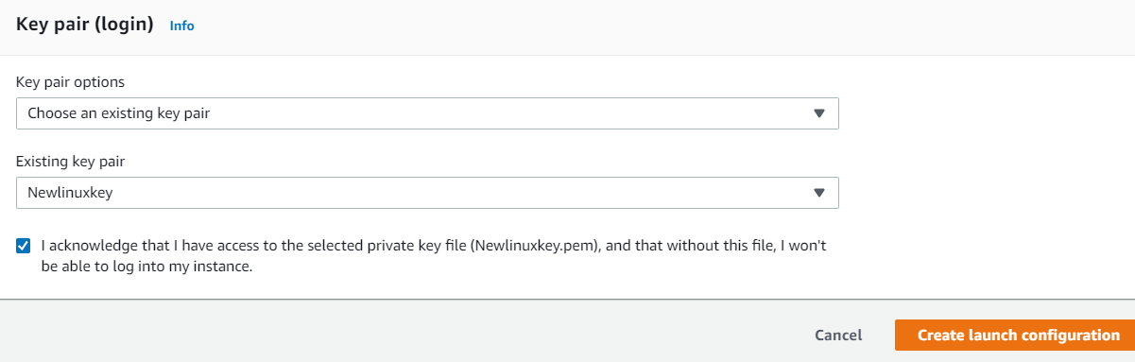

Autoscaling configuration created.

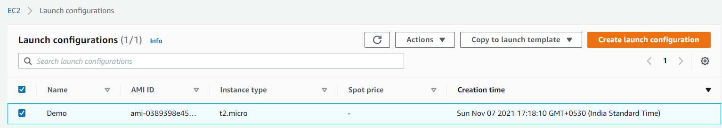

Step5: Create auto scaling group

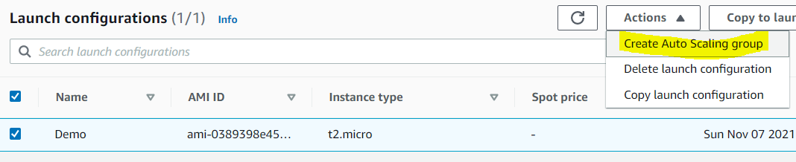

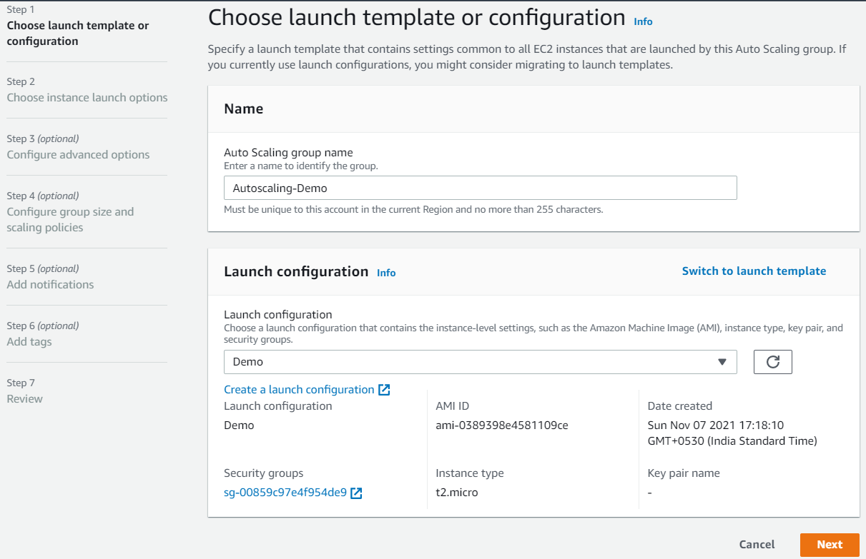

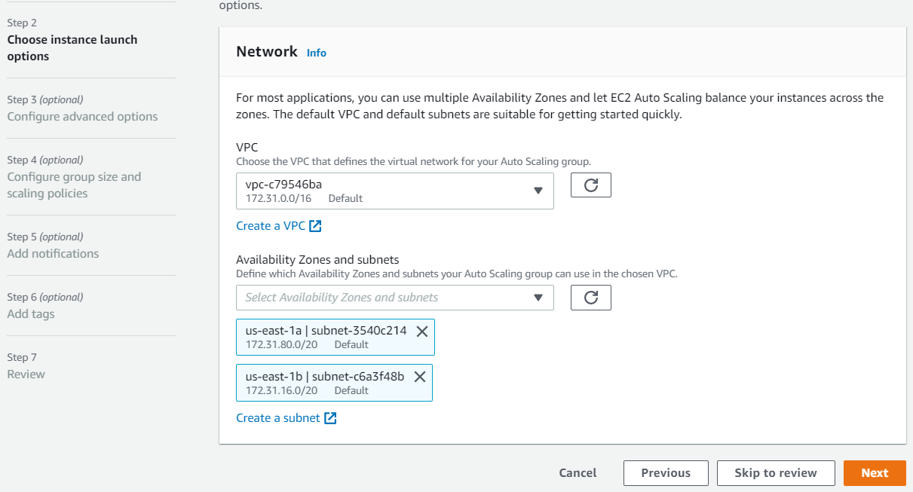

Terminate the Instance for testing.

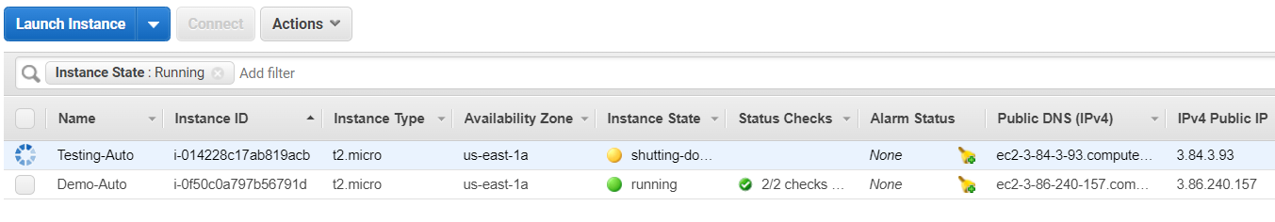

New instance is launching.

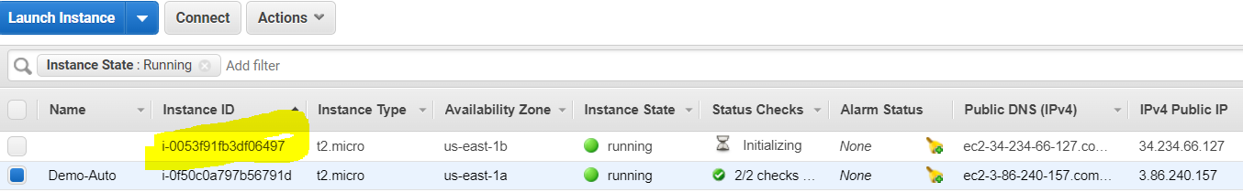

Application running fine without any change

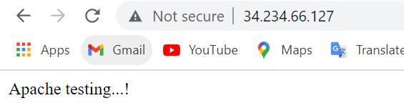

**Deleting Auto scaling:**

